Loan Agreement

I, (insert name of borrower), have borrowed (insert amount borrowed) from (name of lender) for (insert details about the purpose of loan).

The loan will start on (insert starting date of loan), with a fixed interest rate of (insert percentage, i.e. 5%) per year. The loan will be repaid over (insert number of years or months), finishing on (insert end date).

Repayment Terms
Fixed repayment: (insert amount) Monthly/Weekly/Fortnightly, until the loan is repaid
Security: There is no security on the loan
Missed payment: There is no penalty for one missed payment, but a second or subsequent missed payment will attract a (insert percentage, i.e. 5%) charge.

Signed:

(insert your name) – Lender
(insert date)

(insert name of borrower) - Borrower
(insert date)

Example: Loan Agreement

I, Jack Wolfskin, have borrowed $5,000 from Mark Spencer, to pay for urgent repairs on a Subaru Legacy vehicle.

The loan will start on 30 April 2019, with a fixed interest rate of 0% per year. The loan will be repaid over 10 months, finishing on 28 February 2020.

Repayment Terms
Fixed repayment: $500 Monthly, until the loan is repaid
Security: There is no security on the loan
Missed payment: There is no penalty for one missed payment, but a second or subsequent missed payment will attract a 5% charge.

Signed:
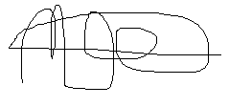
Mark Spencer – Lender
29 April 2019
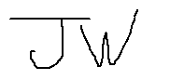
Jack Wolfskin - Borrower
29 April 2019

